SQL QUESTIONS AND QUERIES
13__GROUP BY() and ORDER BY() :
• Find the number of employees in each city.
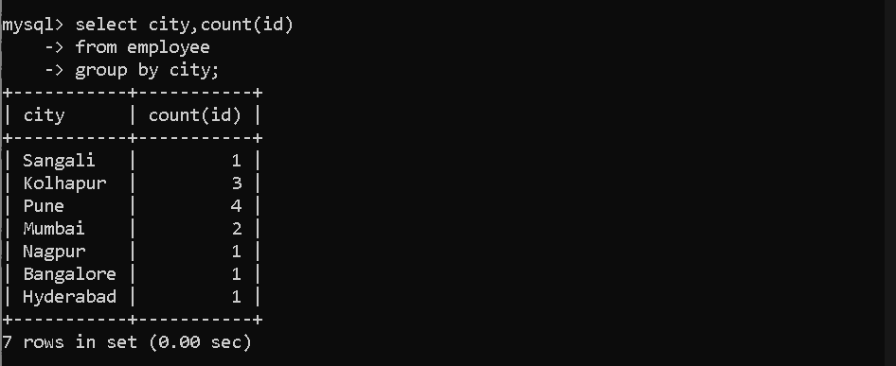
• Find the number of employees in each department.
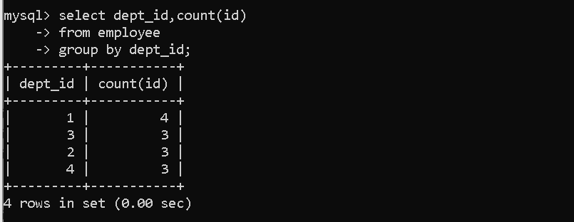
• Find the maximum salary in each department.
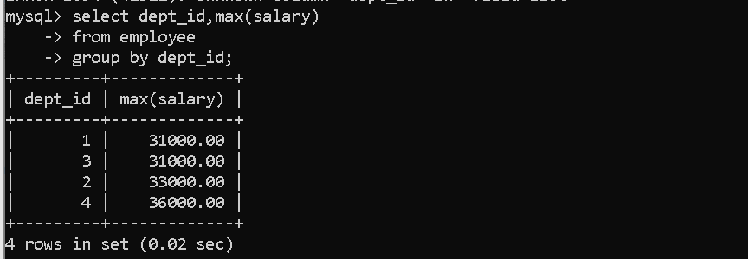
• Display the number of employees based on gender.
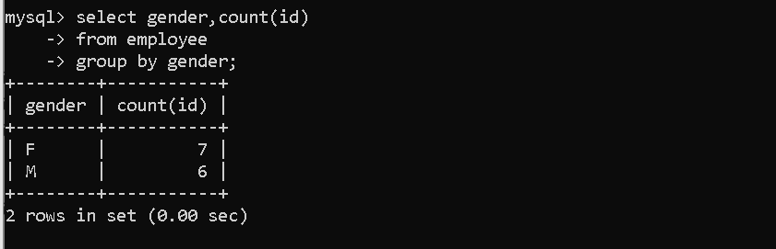
• Find the number of employees in each age group.
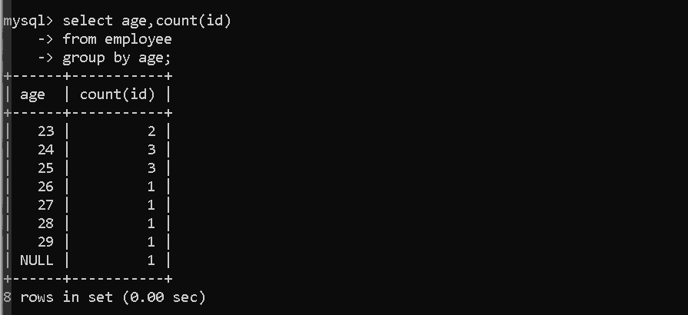
• Find the average salary of employees in each department.
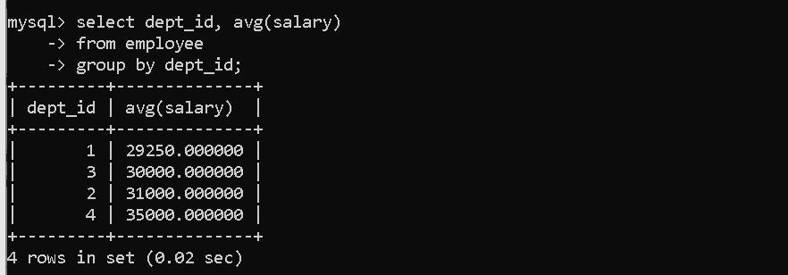
• Display departments whose average salary is greater than 30000.
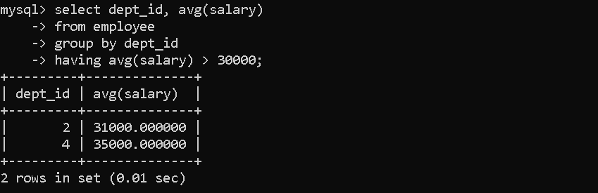
• Display departments 1 and 2 with their average salary.
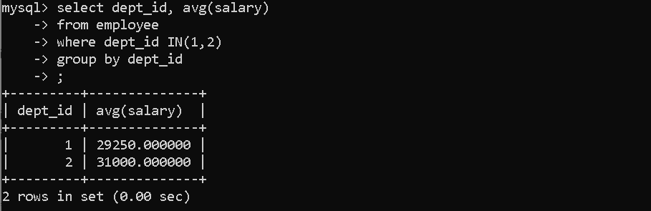
• Display departments that have at least 2 employees.
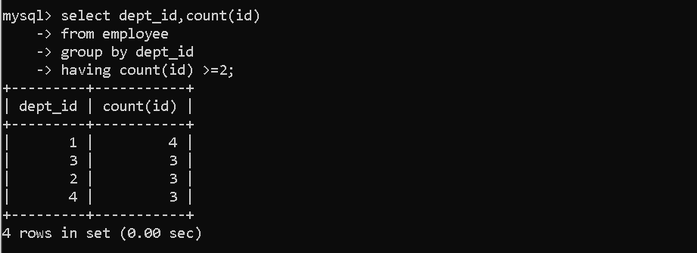
• Display departments 1 and 2 whose average salary is greater than 30000.
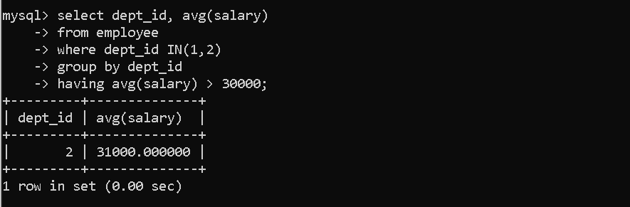
• Display departments sorted by average salary in ascending order.
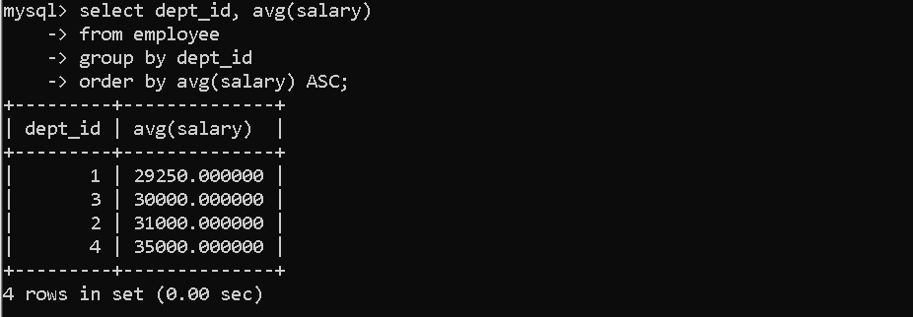
16__GROUP BY() and ORDER BY() and SUB-QUERY() :

- Find the name of the employee who has the highest salary.
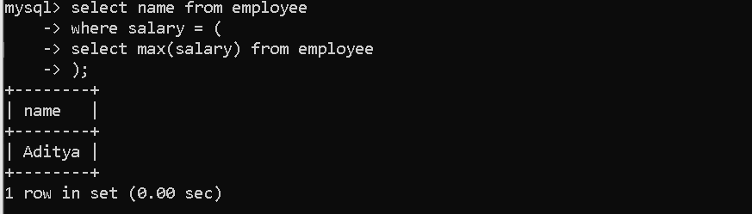
- Find the names of employees whose salary is greater than the average salary of all employees.
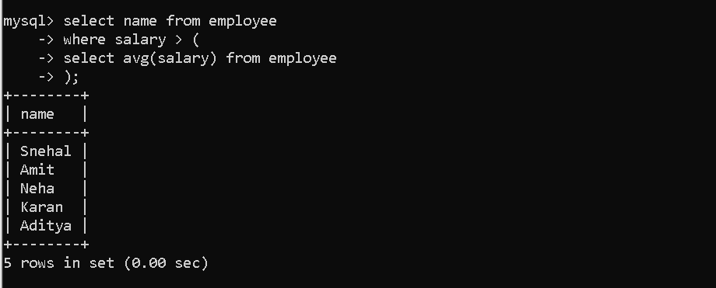
- Find the names of employees who work in the HR department.
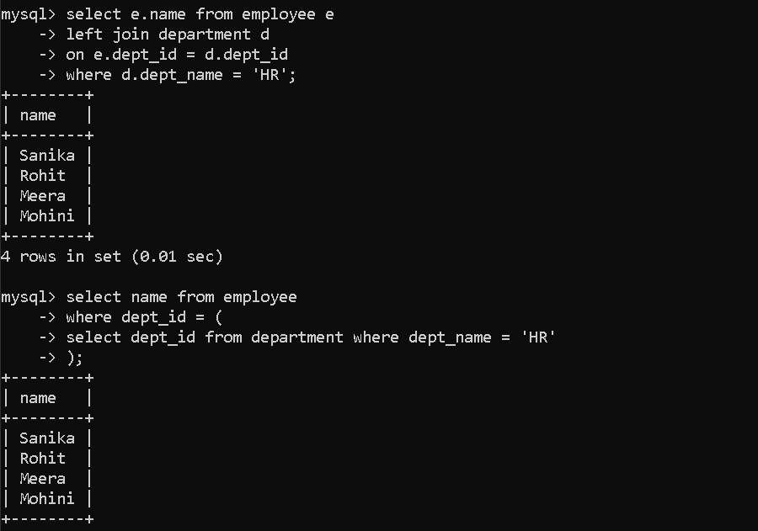
- Find the department name in which the employee with the highest salary works.
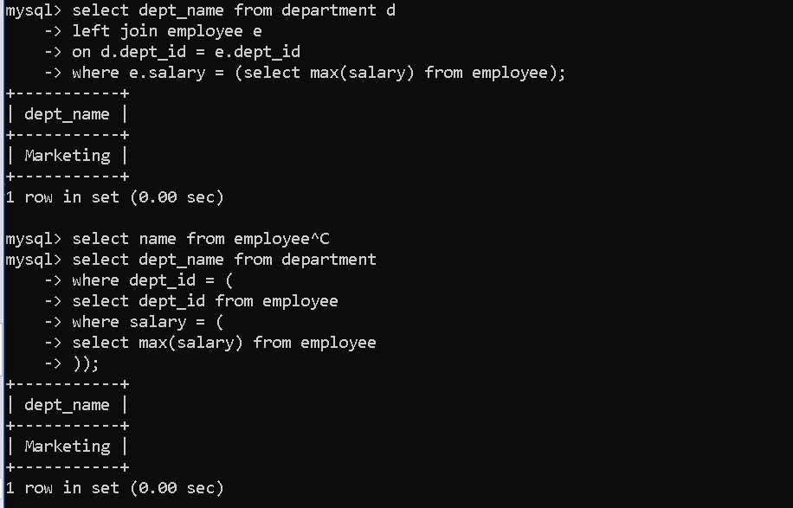
- Find the names of employees who work in departments located in Pune.
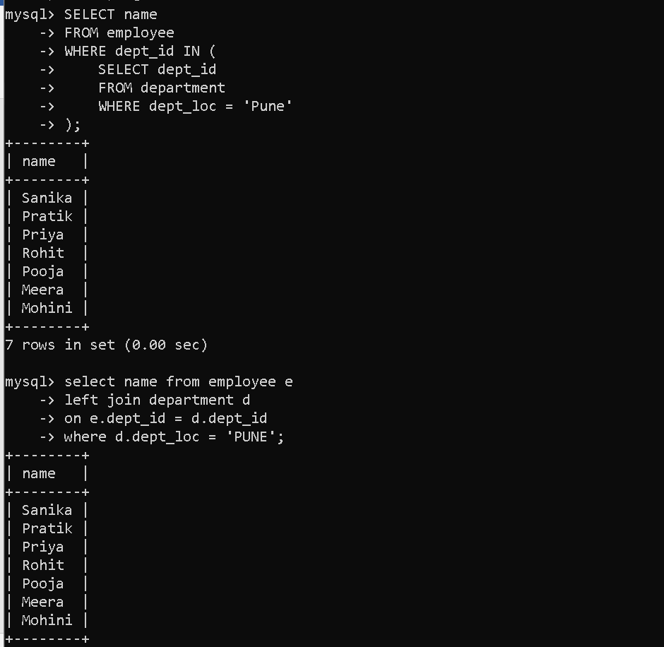

GROUP BY with Multiple Columns — Practice Questions
- Find the number of employees in each city and department.
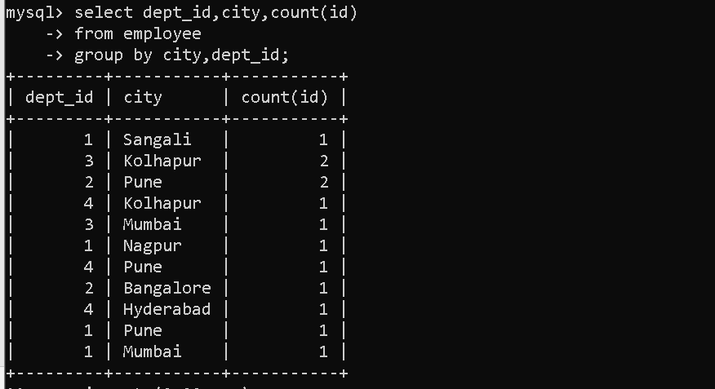
- Display department id, city, and count of employees grouped by city and department.

- Display department id, city, and count of employees sorted by department id.
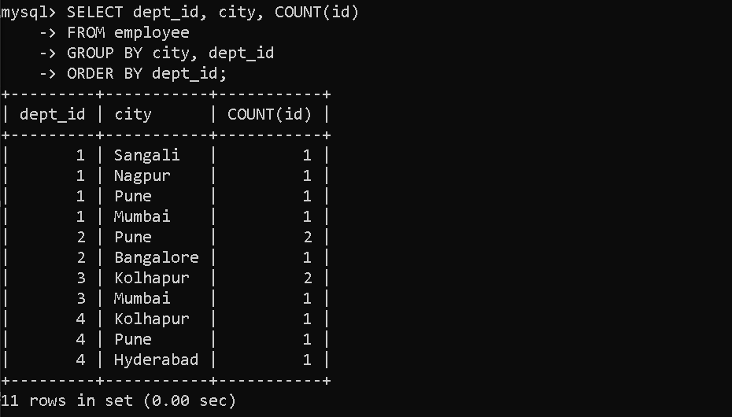
17__AGGREGATE() and FUNCTIONS() :

Subquery
- Find the name, salary, and age of employees who work in the IT department.
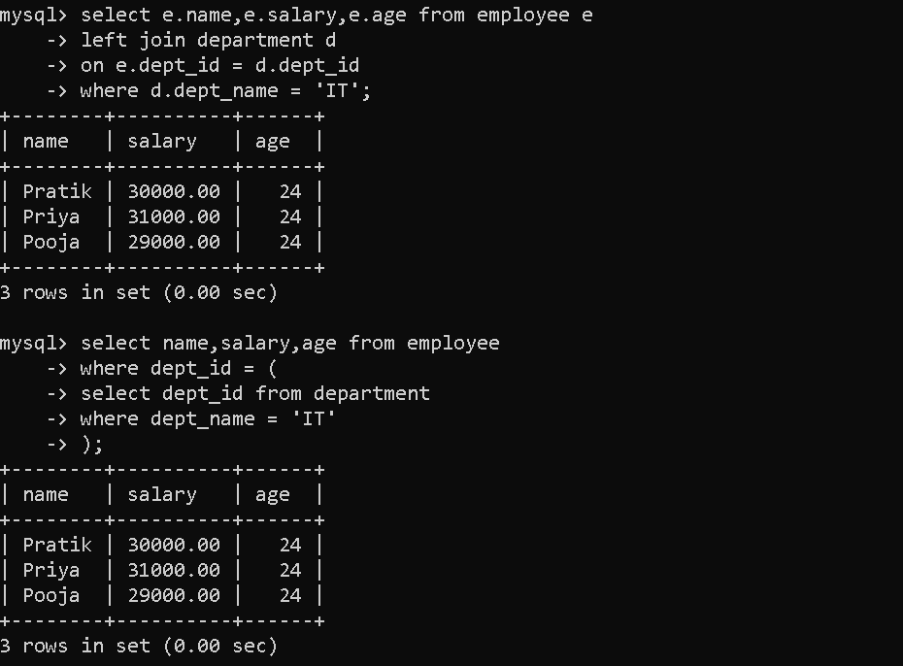

LIKE Operator (Pattern Matching)
- Find employees whose name starts with S.
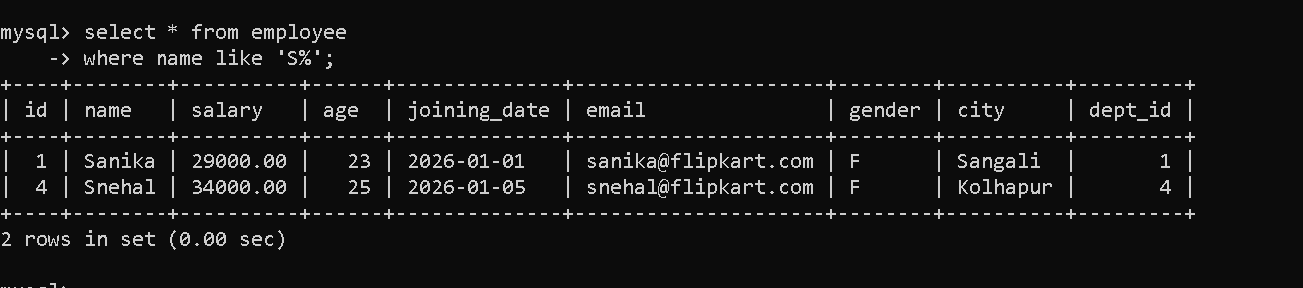
- Find employees whose name ends with a.
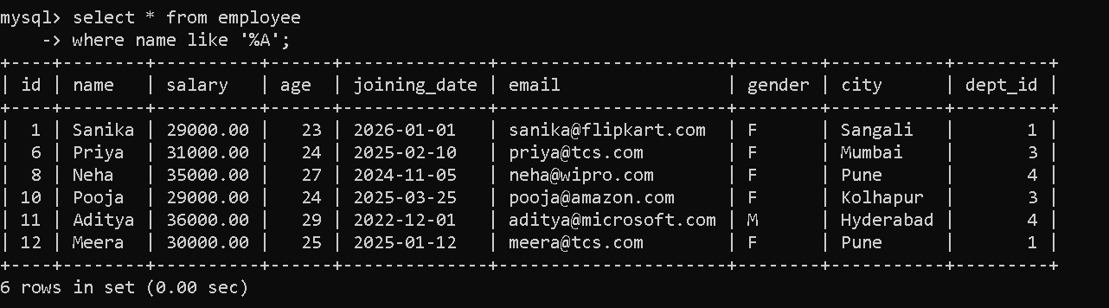
- Find employees whose name contains a anywhere.
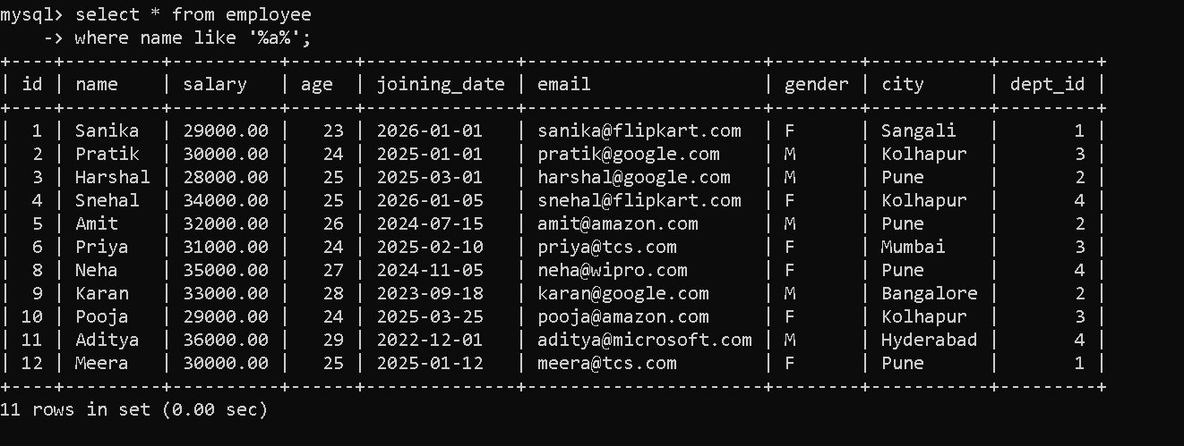
- Find employees whose name contains n.
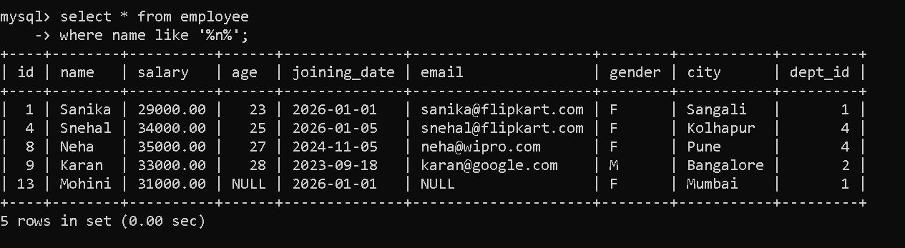
- Find employees whose second letter is a.
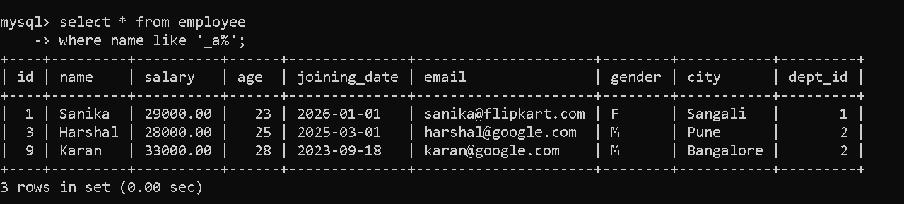
- Find employees whose name matches pattern %a_.
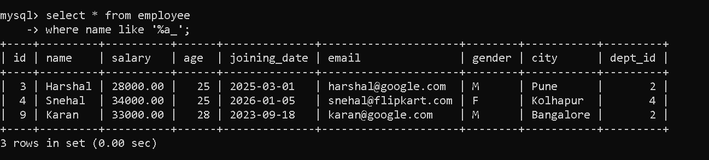
- Find employees whose email belongs to google.com.
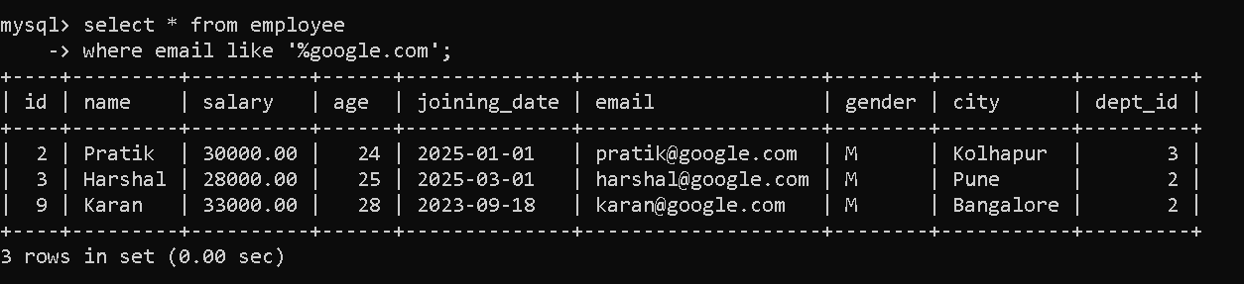
- Display name and email of employees whose email belongs to google.com.
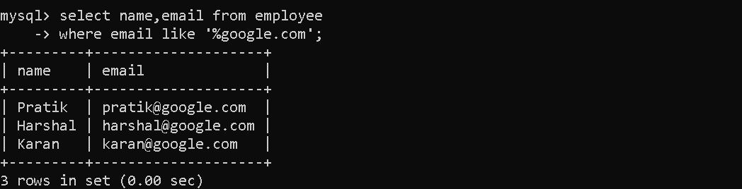
- Find employees whose name matches pattern p_a%.
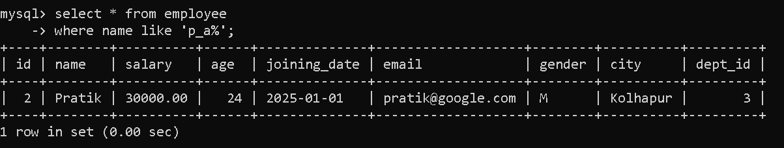

String Functions
- Find the length of string "Virat Kohli".

- Display employee names along with length of their names.
- Display employee names along with length of age values.
- Remove spaces from both sides of a string.
- Remove spaces from the left side of a string.
- Remove spaces from the right side of a string.
- Replace word SQL with MySQL in string.
- Find the position of MySQL in string.
- Extract first 5 characters from a string.
- Extract characters starting from position 5 for length 8.

Number Functions
- Round the number 10.54.
- Round the number 10.44.
- Find the ceiling value of 10.44.
- Find the floor value of 10.74.
- Find remainder when 10 is divided by 2.
- Find remainder when 10 is divided by 3.
- Find square root of 64.
- Find value of 2 power 3.
- Find absolute value of -10.

Aggregate + Number Functions
- Find the average salary of employees.
- Find the rounded average salary of employees.
- Find the floor value of average salary.

